 | SIMATS ENGINEERING  Department of Computer Science and Engineering  CSA15 Cloud Computing and Big Data Analytics  CO2 AT2 - VM Configuration and Security Evidence Workbook  Guided practical workbook for Azure VM, local VM, Docker container, security checks, recovery evidence and GitHub submission
Assessment Metadata
Course Code | CSA15
Course Title | Cloud Computing and Big Data Analytics
Assessment | CO2 AT2 - VM Configuration and Security Evidence
Submission Type | Individual digital workbook based on the same capstone title used in CO1 and CO2 AT1
Faculty | Dr C. Rajesh Babu
Employee ID | SSETSCS415
Submission Mode | Completed workbook, evidence screenshots and GitHub repository link through Google Classroom
How This Workbook Works
- Use the same capstone title carried from CO1 and CO2 AT1.
- Read each procedure block, perform the action, verify the checkpoint and then fill the response table.
- Use Azure first when account activation is available. Use the local VM path when Azure is blocked. Use Docker for container comparison. Use simulation only when practical deployment is blocked.
- Screenshots must show the student's actual configuration or verified simulation work. Hide credentials, keys, tokens and sensitive account details.
- Upload the completed workbook and evidence to GitHub, then submit the GitHub repository link through Google Classroom.
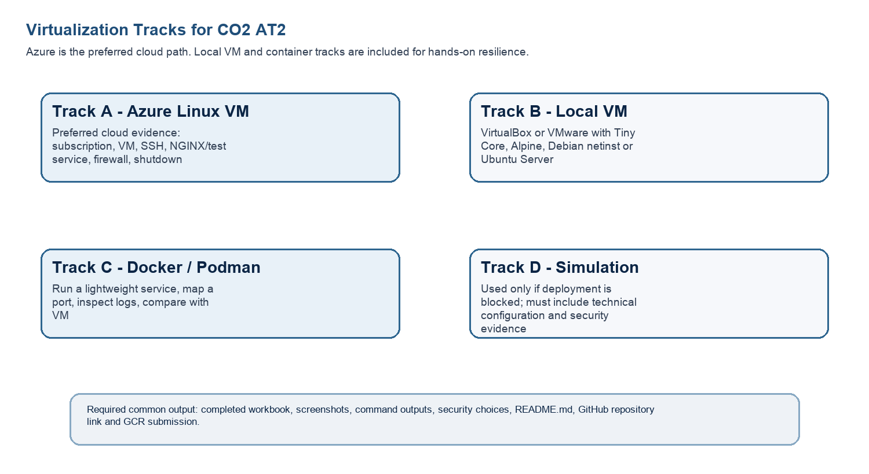
Technical Orientation
The practical work is not limited to clicking through screens. Each checkpoint requires observation: what appeared on screen, why it appeared, what it proves and how it connects to the capstone infrastructure plan.
Part 1: Student and Capstone Baseline
Student Name | J Bharath
Register Number | 192511234
Class / Slot | Slot B
Capstone Title | SkillForge-CO-Attainment Cloud Tutor Using Recommendation Analytics
CO2 AT1 Recommended VM Size | vCPU: 8 RAM: 32 GB Disk: 100 GB SSD
Selected Practical Track | Azure VM (in progress) and Local VM (completed); Docker attempted, troubleshooting in progress
GitHub Repository Link | To be added after GitHub repository is created and evidence uploaded
Google Classroom Submission Date | Pending - to be recorded at final submission
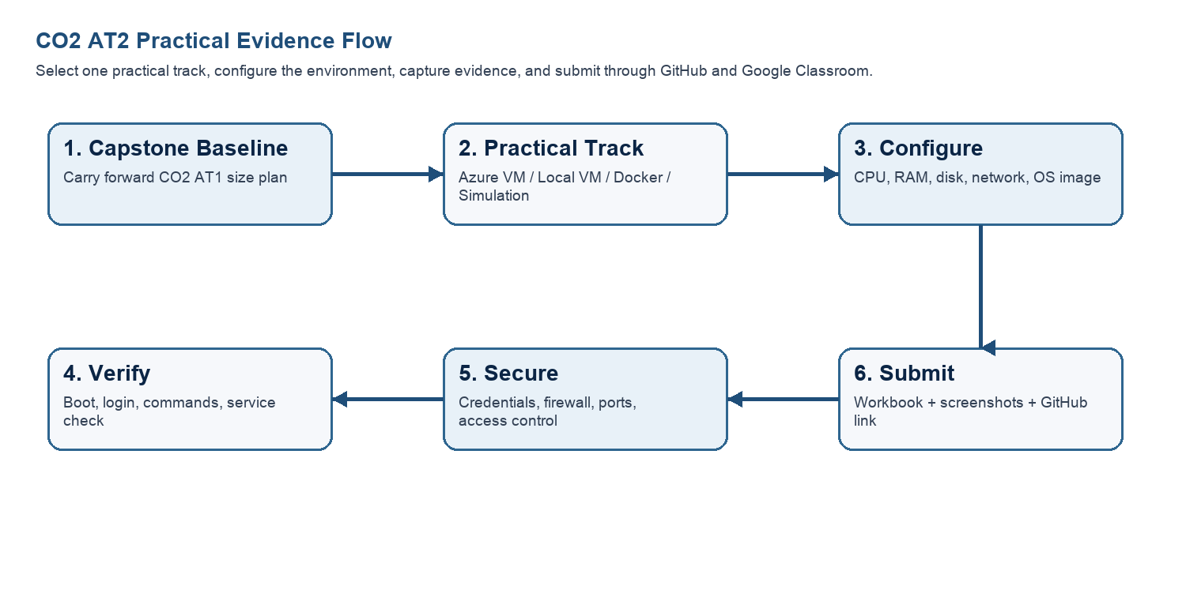
Capstone Infrastructure Element | Carry-Forward from CO2 AT1
Workload type | AI/Python module (primary - recommendation engine), with Analytics app and Database-heavy app as secondary characteristics (carried from CO2 AT1)
Main application modules | Login/Auth, Student Dashboard, Quiz/Assessment, CO-Attainment Tracker, Recommendation Engine, Faculty Upload Portal, Analytics Dashboard
Expected users / traffic assumption | 1000 registered users; ~10% daily active (~250 DAU); peak factor 2 gives ~10 RPS at peak (from CO2 AT1 traffic calibration)
Database need | Yes - student records, CO mapping and quiz scores; planned as a managed database service
File storage need | Yes - course materials and assignment PDFs; planned as object storage, not VM disk
AI/Python/analytics need | Yes - recommendation engine is the core differentiating feature of the capstone
Security concern | Protecting student CO-attainment records and credentials; keeping inbound ports minimal and hiding all secrets from evidence screenshots
Recovery concern | Snapshot before deployment/demo/update; managed database backup for the production database tier
Part 2: OS Image Selection Guide
Select the operating system image based on the available network, device capacity and learning objective. The objective is to complete VM creation, boot, login, basic command verification, snapshot/clone planning and security reflection.
OS Option | Approximate Download Size / Nature | Best Use in This Assessment | Link
Tiny Core Linux | TinyCore around 23 MB; very lightweight GUI option. | Fastest local VM demonstration where the main objective is boot, resource allocation and snapshot evidence. | https://distro.ibiblio.org/tinycorelinux/downloads.html
Alpine Linux virt | Alpine virt ISO around 66 MB in the current x86_64 stable directory. | Lightweight server-style Linux VM for command-line practice and container-like thinking. | https://dl-cdn.alpinelinux.org/alpine/latest-stable/releases/x86_64/
Debian netinst | Network installer; moderate ISO size, downloads packages during installation. | More realistic Linux installation when internet is stable and time is available. | https://www.debian.org/download
Ubuntu Server | Larger server ISO; familiar cloud VM image. | Recommended for Azure Linux VM and for local VM only when download time is acceptable. | https://ubuntu.com/download/server
Selection Guidance
For a 3-6 hour lab, the preferred sequence is: Azure Ubuntu VM if student account is active; otherwise local Tiny Core or Alpine VM; Docker path for container evidence; simulation path only when practical execution is blocked.
Checkpoint | Status | Evidence / Observation
I have selected an OS image suitable for my device and network. | [X] Yes [ ] Rework | Ubuntu Server LTS selected for the planned Azure VM; Tiny Core Linux selected for the local VirtualBox VM - both fit lab device and network constraints
I have recorded the official download page or cloud image name. | [X] Yes [ ] Rework | Tiny Core Linux: distro.ibiblio.org/tinycorelinux; Azure image: Ubuntu Server 24.04 LTS (Azure Marketplace)
I have checked whether the ISO is small enough for the lab duration. | [X] Yes [ ] Rework | Tiny Core ISO (~23 MB) confirmed lightweight; Azure Ubuntu image is a managed cloud image so no local download is needed
Student Entry: Selected OS image, version, reason and link used

Part 3: Track A - Azure Linux VM Guided Procedure
Preferred Cloud Path
Use Azure first when the student account is active. Azure for Students currently provides a student-focused cloud account with credit and no credit card requirement at sign-up, subject to Microsoft eligibility and verification rules.
Azure for Students: https://azure.microsoft.com/en-us/free/students
Azure for Students offer details: https://azure.microsoft.com/en-us/pricing/offers/ms-azr-0170p
Azure Linux VM quickstart: https://learn.microsoft.com/en-us/azure/virtual-machines/linux/quick-create-portal
A. Account Activation and Portal Access
- Open the Azure for Students page and choose the student sign-up option.
- Sign in using the official student email account when available.
- Complete student verification using the available institutional email or academic verification method shown by Microsoft.
- Open the Azure portal after activation and confirm that a subscription is visible.
- Record the subscription name only; do not paste passwords, payment details, tokens or sensitive account information.
Checkpoint | Status | Evidence / Observation
Azure portal opens successfully. | [X] Yes [ ] Rework | Azure for Students overview page confirmed account active with full credit balance ($9,439) available
A student or valid Azure subscription is visible. | [X] Yes [ ] Rework | Azure for Students subscription visible and active in the portal
The student understands that resources must be stopped or deleted after evidence capture. | [X] Yes [ ] Rework | Understood - the VM will be stopped/deallocated or deleted after evidence capture to protect the student credit
Evidence Space: Paste account activation/portal screenshot with sensitive details hidden
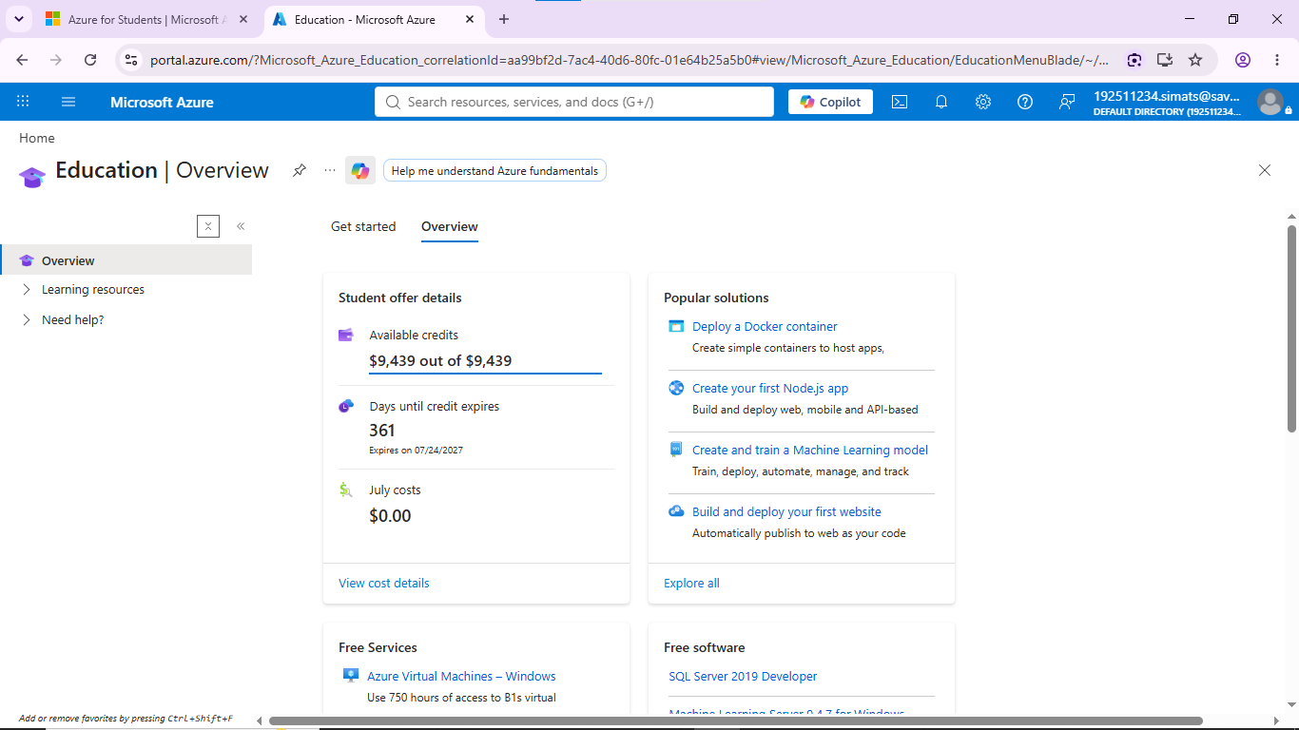
B. Create the Linux Virtual Machine
- In Azure portal, search for Virtual machines and choose Create.
- Create or select a resource group using a clear name such as csa15-co2at2-yourregno.
- Enter a VM name such as csa15-vm-yourregno.
- Select a nearby Azure region available in the subscription.
- Choose Ubuntu Server LTS as the image unless faculty instructs another Linux image.
- Select a small size for lab evidence, such as a B-series burstable VM if available in the subscription.
- Select SSH public key or password according to faculty guidance. Do not share credentials in the workbook.
- Allow SSH port 22 only when required. If a web service is tested, add HTTP port 80 only for the test window.
- Review and create the VM. Wait until deployment succeeds.
Azure Setting | Student Value
Resource group | csa15-co2at2-192511234 (planned)
VM name | csa15-vm-192511234 (planned)
Region | Pending deployment - nearest available region in subscription
Image | Ubuntu Server 24.04 LTS (planned)
VM size | B-series burstable, e.g. B1s (planned)
vCPU | Pending deployment
RAM | Pending deployment
Disk type and size | Pending deployment
Authentication method | SSH key / password - do not paste secret
Open inbound ports | SSH (22) only - planned
Checkpoint | Status | Evidence / Observation
VM deployment status shows success. | [ ] Yes [X] Rework | VM not yet deployed - deployment step pending at time of this workbook entry
VM overview page shows running status. | [ ] Yes [X] Rework | Pending VM creation
Public IP or connection method is visible. | [ ] Yes [X] Rework | Pending VM creation
The selected VM size is compared with CO2 AT1 sizing recommendation. | [ ] Yes [X] Rework | To be completed once deployed - planned burstable size is intentionally much smaller than the CO2 AT1 production estimate (8 vCPU/32GB) since this is lab evidence, not production scale
Evidence Space: Paste VM overview and configuration screenshot

C. Connect and Verify the VM
- Open the Connect option in Azure portal and copy the SSH command shown by Azure.
- Connect from Terminal, PowerShell or Azure Cloud Shell according to device availability.
- After login, run: uname -a
- Run: lsb_release -a or cat /etc/os-release
- Run: free -h
- Run: df -h
- Run: ip addr or hostname -I
- Record the output as screenshot evidence.
Verification Command | Expected Purpose | Student Observation
uname -a | Kernel and OS environment | Pending - VM not yet deployed
cat /etc/os-release | Linux distribution details | Pending - VM not yet deployed
free -h | RAM allocation | Pending - VM not yet deployed
df -h | Disk allocation | Pending - VM not yet deployed
hostname -I | Private IP / network evidence | Pending - VM not yet deployed
Evidence Space: Paste command output screenshot or copied terminal output
D. Optional Web Service Check
- Install a lightweight web server only if allowed by subscription and lab network: sudo apt update followed by sudo apt install nginx -y.
- Start or verify the service: systemctl status nginx.
- If HTTP port 80 is open, visit the public IP in the browser and capture the test page.
- If port 80 is not opened, record the reason and keep SSH-only evidence.
Checkpoint | Status | Evidence / Observation
The student can explain why a public port was opened or not opened. | [ ] Yes [X] Rework | Not reached yet - Azure VM not deployed
The service status or browser test was captured. | [ ] Yes [X] Rework | Not reached yet
The public exposure was kept temporary for the assessment. | [ ] Yes [X] Rework | N/A - no service deployed yet
E. Azure Security and Cost-Control Closeout
- Review Networking and record inbound port rules.
- Confirm that no unnecessary public ports are open.
- Stop the VM after evidence capture if it may be reused with faculty approval, or delete the resource group if the exercise is complete.
- Capture stopped/deallocated or deletion evidence.
- Record what would change for a production capstone deployment.
Security / Cost-Control Item | Student Evidence / Decision
Inbound ports allowed | Planned: SSH (22) only
Authentication method used | Planned: SSH key
Public IP required? | Planned: yes, temporarily, for SSH access only
Stopped/deallocated or deleted? | Not yet deployed
Reason for closeout choice | N/A - pending deployment
Evidence Space: Paste networking rule and shutdown/deletion screenshot

Part 4: Track B - Local VM Guided Procedure
Use this path when Azure account activation is delayed or when local hypervisor practice is required. VirtualBox is recommended for broad accessibility. VMware Workstation/Fusion may be used where available.
VirtualBox downloads: https://www.virtualbox.org/wiki/Downloads
VMware Workstation and Fusion: https://www.vmware.com/products/desktop-hypervisor/workstation-and-fusion
A. Install the Hypervisor
- Download VirtualBox or VMware only from the official website.
- Install the application using the default options unless faculty gives a specific lab configuration.
- Restart the system if the installer requests it.
- Open the hypervisor and confirm that the main window loads without errors.
- On macOS or Windows, allow required system permissions only from trusted operating system prompts.
Item | Student Entry
Hypervisor selected | VirtualBox
Version | Not captured from screenshot - to confirm via Help > About VirtualBox
Host operating system | Windows
Host CPU and RAM | Not captured - to confirm via System Information
Reason for selected hypervisor | VirtualBox is free, widely available and sufficient for lightweight Linux VM lab evidence
Checkpoint | Status | Evidence / Observation
Hypervisor opens successfully. | [X] Yes [ ] Rework | VirtualBox opened and the VM window is running (Tiny Core boot screen visible)
Student can locate New VM/Create VM option. | [X] Yes [ ] Rework | VM created and named csa15-localvm-192511234
Student has downloaded or selected a suitable OS image. | [X] Yes [ ] Rework | Tiny Core Linux selected as the lightweight OS image
B. Create the VM
- Choose New VM or Create a New Virtual Machine.
- Enter a clear VM name such as csa15-localvm-yourregno.
- Select Linux as the type and the closest version available.
- Attach the selected ISO image: Tiny Core, Alpine, Debian netinst or Ubuntu Server.
- Allocate CPU based on CO2 AT1 sizing, but keep within safe host limits.
- Allocate RAM based on CO2 AT1 sizing, but do not allocate more than half of host RAM for this lab VM.
- Create a virtual disk. For Tiny Core or Alpine, 2-8 GB is enough for evidence. For Debian/Ubuntu, use 15-25 GB when storage permits.
- Finish creation and start the VM.
VM Setting | Recommended Lab Range | Student Value
VM name | csa15-localvm-192511234
OS image | Tiny Core Linux
vCPU | Not captured from screenshot - to confirm in VM settings
RAM | Not captured from screenshot - to confirm in VM settings
Virtual disk | Not captured from screenshot - to confirm in VM settings
Network mode | NAT (default; to confirm in VM network settings)
Display / boot mode | Default
Host Safety Guidance
Do not allocate all host resources to the VM. Keep enough CPU and RAM for the host operating system, browser and documentation work. If the host has 8 GB RAM, a 1 GB or 2 GB VM is more appropriate than a 6 GB VM.
Evidence Space: Paste VM settings screenshot before first boot
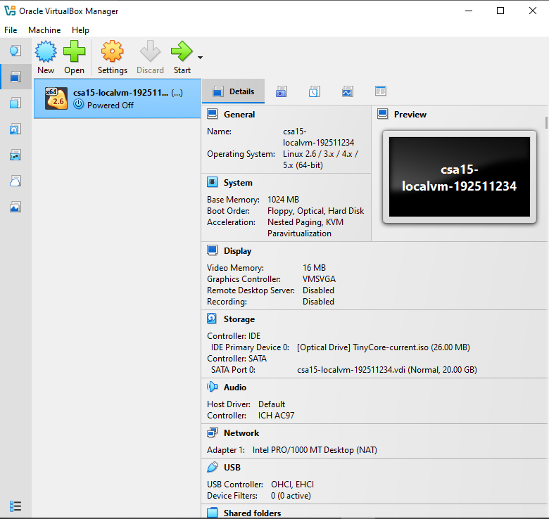
C. Boot and Verify the VM
- Start the VM and wait for the OS boot screen.
- For Tiny Core, confirm that the graphical desktop appears.
- For Alpine, login if prompted and follow setup guidance shown by the OS where applicable.
- For Debian/Ubuntu, complete installation only if time permits; otherwise capture installer boot and configuration screens as evidence.
- Open terminal inside the VM where possible.
- Run or record equivalent commands: uname -a, free -h, df -h and ip addr.
Checkpoint | Status | Evidence / Observation
VM starts without boot error. | [X] Yes [ ] Rework | Tiny Core boot logo displayed; VM running without boot error
OS screen or terminal is visible. | [X] Yes [ ] Rework | Tiny Core boot screen visible; terminal command verification still pending
CPU/RAM/disk allocation is verified. | [ ] Yes [X] Rework | Allocation not yet confirmed via terminal commands (uname -a, free -h, df -h) - pending
Network mode is recorded. | [X] Yes [ ] Rework | NAT mode (default) recorded
Evidence Space: Paste VM boot/login/terminal screenshots
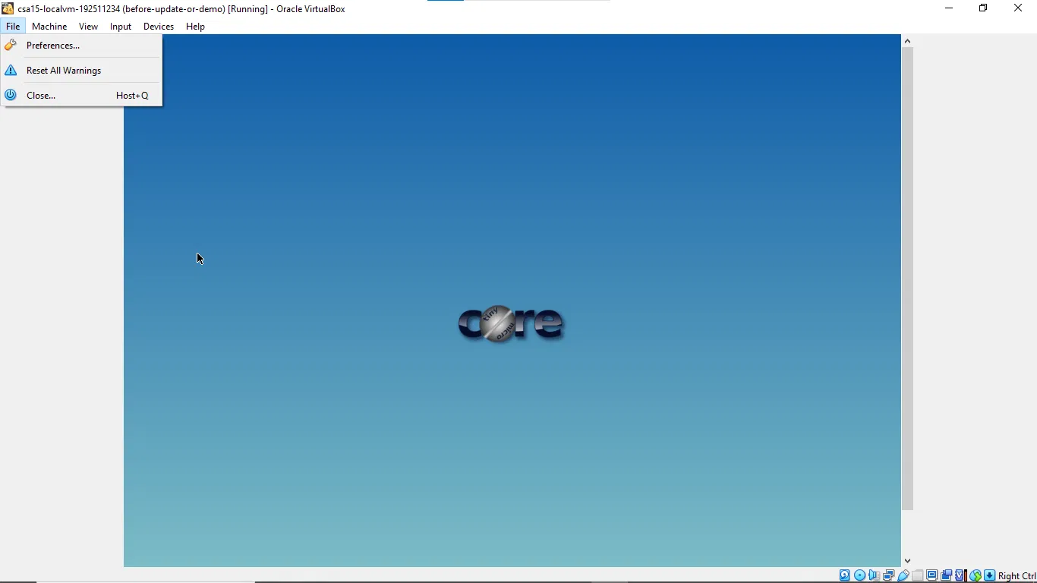

D. Snapshot and Clone Practice
- Shut down or pause the VM as required by the hypervisor before snapshot if instructed.
- Create a snapshot named before-update-or-demo.
- Record snapshot name, date and reason.
- Create a linked clone or full clone if the device has enough storage. If not, write the reason and create a clone plan.
- Start the VM again and confirm it still boots.
Recovery Item | Student Evidence / Decision
Snapshot name | before-update-or-demo
Snapshot timing | Taken before update/demo session (visible in VM window title)
Snapshot reason | Rollback point in case an update or demo configuration change causes issues
Clone attempted? | No
Clone type | Not attempted
Storage impact observed | To be recorded if a clone is attempted
Evidence Space: Paste snapshot manager and clone wizard/evidence screenshot

E. Local VM Security Reflection
Security Area | Student Decision
VM network mode | NAT
Why this mode is selected | NAT gives the VM internet access while isolating it from the local network - a safe default for lab use
Guest password policy | Not captured - to confirm
Shared folders enabled? | No
Clipboard/drag-drop enabled? | No
Risk if VM is exposed to public network | Tiny Core has minimal hardening by default; exposing it to a public network without firewall/authentication hardening would risk unauthorized access

Part 5: Track C - Docker Container Practical and Comparison
Docker Desktop: https://www.docker.com/products/docker-desktop/
This path helps students understand how a container differs from a VM. A VM virtualizes hardware and runs a guest OS. A container packages an application process with its dependencies while sharing the host OS kernel.
Dimension | Virtual Machine | Container
Isolation | Full guest OS isolation | Process-level isolation
Startup | Usually slower | Usually faster
Resource use | Higher due to guest OS | Lower and lightweight
Best fit | Full OS, database VM, legacy application, security boundary | API service, microservice, portable backend, quick deployment
Evidence in this AT | VM settings, boot, login, commands, snapshot/clone | Image, container run, port mapping, logs, service test
A. Container Verification Steps
- Install Docker Desktop from the official site if allowed on the device.
- Open Terminal or PowerShell and run: docker --version.
- Run a lightweight container such as: docker run --rm hello-world.
- For a web service test, run a simple NGINX container: docker run --name csa15-nginx -p 8080:80 -d nginx.
- Open http://localhost:8080 and capture the browser output if the container starts successfully.
- Check logs using: docker logs csa15-nginx.
- Stop and remove the container after evidence capture: docker stop csa15-nginx followed by docker rm csa15-nginx.
Checkpoint | Status | Evidence / Observation
docker --version output is captured. | [ ] Yes [X] Rework | Docker Desktop fails to start - 'Virtualization support not detected'; troubleshooting in progress (wsl --update running)
A container run command is captured. | [ ] Yes [X] Rework | Not yet - blocked by Docker Desktop startup failure
Port mapping or service evidence is captured if web test is used. | [ ] Yes [X] Rework | Not yet captured
Container logs or status are captured. | [ ] Yes [X] Rework | Not yet captured
Container is stopped/removed after evidence capture. | [ ] Yes [X] Rework | N/A - no container has been run yet
Docker Evidence | Student Observation
Docker version | Docker Desktop v4.84.0 installed; engine not yet started
Image used | Planned: hello-world, then nginx
Container name | Planned: csa15-nginx
Port mapping | Planned: 8080:80
Service URL tested | Planned: http://localhost:8080
Log/status observation | Docker Desktop currently blocked by virtualization detection error; fix in progress (WSL2 kernel update running via wsl --update)
Stop/remove evidence | Pending
Evidence Space: Paste Docker command and browser/service screenshots
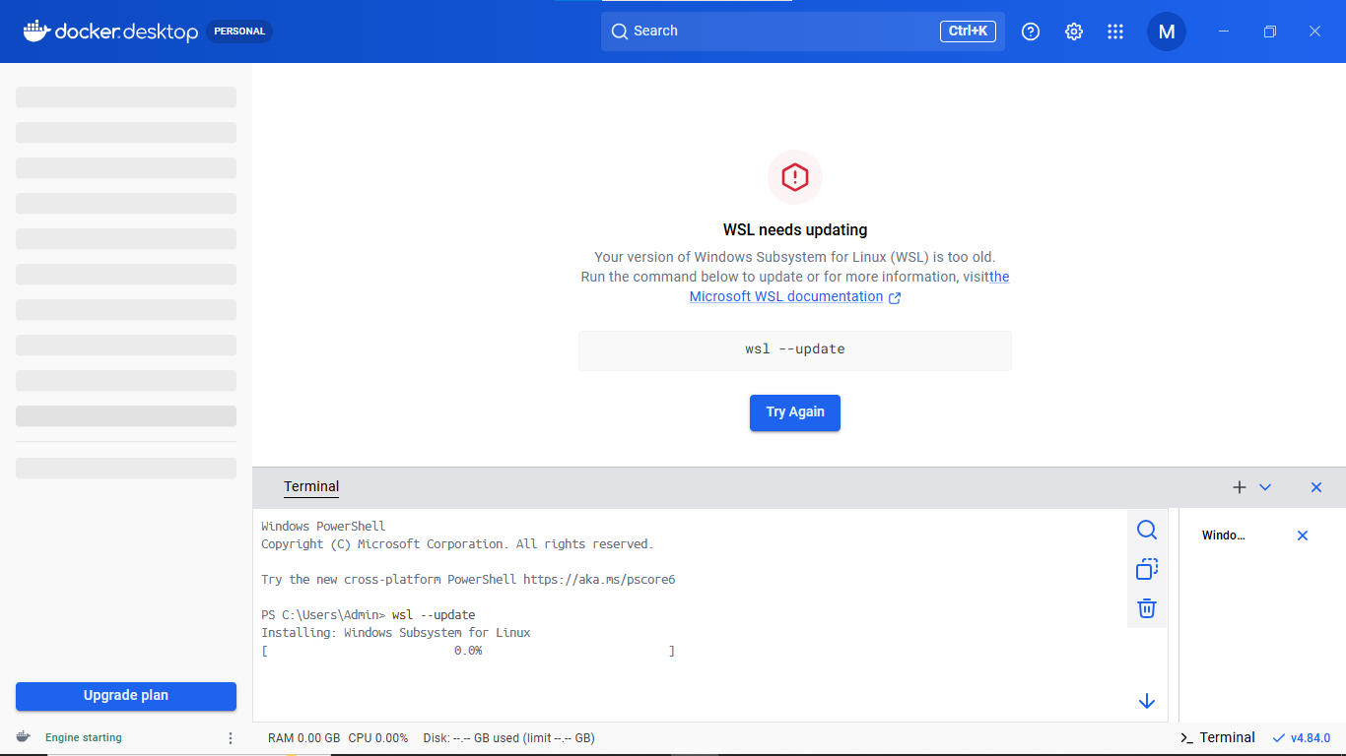
B. Capstone Module Decision
Capstone Module | VM / Container / Managed Service | Technical Reason
Frontend | Managed Service | Static hosting + CDN for the web UI is cheaper and faster than a dedicated VM
Backend/API | VM | Core API needs a persistent process, direct DB connectivity and steady compute for auth/session logic
Database | Managed Service | Reliability, automated backup and scaling are critical for CO-attainment records
File storage | Managed Service | Object storage handles learning-resource uploads without consuming VM disk
AI/Python module | Container | Recommendation engine is packaged as a portable, independently scalable microservice
Analytics/dashboard | Container | Aggregation/reporting jobs scale out independently from the core API
Notification/background job | Container | Lightweight event-driven jobs suit fast container startup
C. Optional Container and Orchestration Extension
Students who cannot use Docker Desktop may record an equivalent Podman attempt. Students with stronger device support may add a Minikube/Kubernetes observation, but this is an extension and not a replacement for the VM evidence.
Podman: https://podman.io/
Minikube: https://minikube.sigs.k8s.io/docs/start/
Kubernetes documentation: https://kubernetes.io/docs/home/
Optional Tool | Possible Evidence | Student Observation
Podman | Not attempted
Minikube | Not attempted
Kubernetes | Not attempted

Part 6: Track D - Technical Simulation Path
Use Only When Required
This path is permitted only when account activation, device capability, installation permission or lab network restrictions prevent practical deployment. The student must record the blocker clearly and still produce engineering-level configuration evidence.
CloudSim: https://github.com/Cloudslab/cloudsim
Simulation Artifact | Required Content
Blocker statement | Not applicable - Azure and Docker tracks are being completed practically; simulation path not used
VM configuration table | N/A
Security table | N/A
Snapshot/clone plan | N/A
Command plan | N/A
Architecture diagram | N/A
Risk analysis | N/A
Blocker Evidence and Justification

Planned Configuration | Student Value
Platform | Azure / VirtualBox / VMware / Docker
OS image | N/A
vCPU | N/A
RAM | N/A
Disk | N/A
Network mode / firewall | N/A
Access method | N/A
Service to verify | N/A
Paste or draw the simulation architecture diagram here

Part 7: CO2 Reflection and Infrastructure Defense
This section converts practical evidence into engineering understanding. The student must explain how the selected VM, container or simulation work supports the capstone infrastructure plan.
Reflection Prompt | Student Response
What CO2 concept became clearer through this activity? | The practical difference between VM-level virtualization (VirtualBox, Azure VM) and container-level isolation (Docker) - including OS boot behaviour, resource allocation and network modes
How did the practical configuration confirm or challenge the CO2 AT1 VM sizing estimate? | CO2 AT1 recommended 8 vCPU/32GB RAM/100GB SSD for the full production-scale AI workload; the lab evidence VMs (Tiny Core local VM, planned Azure B-series) are deliberately much smaller because they demonstrate configuration and security mechanics rather than full recommendation-engine inference capacity
Which evidence proves that CPU, RAM, disk, OS image and network settings were understood? | VM creation with named resources, Tiny Core boot verification, snapshot naming (before-update-or-demo), and planned terminal verification commands (uname -a, free -h, df -h, hostname -I) for the Azure VM
Which security decision is most important for the capstone product and why? | Restricting inbound ports to SSH only (22) and avoiding public exposure of services until explicitly required and time-boxed, since the capstone handles sensitive student CO-attainment records
What will be carried forward from CO2 AT2 to CO2 AT3 infrastructure defense? | The two-tier design (app VM + managed database), the containerized recommendation engine, snapshot/rollback discipline, and a minimal open-port security posture
Short Defense Statement: In 8-10 technical lines, defend whether the selected VM/container setup is suitable for the capstone prototype.
The current setup is a reasonable early-stage validation, not yet the final capstone footprint. The local VirtualBox VM confirms basic boot, resource allocation and snapshot rollback discipline (before-update-or-demo), which mirrors how the production app VM will be protected before updates and demos. The planned Azure B-series VM validates cloud deployment mechanics (region, image, SSH-only access) on the exact platform chosen for the pilot, even though its size is intentionally far below the CO2 AT1 estimate of 8 vCPU/32GB, since this AT is about correctness of configuration, not full inference load. Docker is the right fit for the recommendation engine and analytics jobs because it isolates and scales the AI/Python workload independently of the core API, matching the CO2 AT1 VM/container decision table. The current Docker Desktop virtualization error is a host-configuration issue, not a design flaw, and is being resolved via a WSL2 kernel update. Overall, the VM/container mix is suitable for the prototype stage; it will need to move to the full two-tier design with a managed database once real user traffic is introduced.

Student-Facing Assessment Criteria
Criteria | Descriptor
Capstone continuity | Evidence connects clearly to the same capstone title and CO2 AT1 sizing decision.
Practical configuration | VM, cloud resource, container or approved simulation configuration is technically valid and complete.
Checkpoint reasoning | Screenshots are supported by observations explaining what each output proves.
Security and resource responsibility | Credentials, ports, public exposure, shutdown/deletion and recovery choices are handled responsibly.
Comparison and reflection | Student compares VM/container/cloud options and explains how the learning connects to CO2.
Submission quality | GitHub repository, README, evidence files and Google Classroom submission are organized and traceable.
Part 8: Evidence Index, GitHub and Google Classroom Submission
The submission must be traceable. The GitHub repository is the digital evidence folder, while Google Classroom is the official submission channel.
Repository Item | Expected Content
README.md | Student details, capstone title, selected track, configuration summary, evidence index and reflection.
Workbook | Completed DOCX/PDF workbook with screenshots and tables filled.
Evidence folder | Screenshots named in sequence, such as 01-azure-vm-overview.png.
Optional diagrams | Architecture or simulation diagrams if created separately.
Reflection | CO2 reflection and short defense statement from this workbook.
Evidence No. | File / Screenshot Name | What It Proves
1 | 01-azure-account-activation.png | Confirms Azure for Students subscription is active with full credit balance
2 | 02-docker-desktop-error.png | Shows the initial Docker Desktop virtualization error and the troubleshooting starting point
3 | 03-localvm-tinycore-running.png | Shows the VirtualBox VM running Tiny Core Linux with the before-update-or-demo snapshot label visible
4 | Pending | To be added once the Azure VM is deployed
5 | Pending | To be added once terminal verification commands are captured
6 | Pending | To be added once Docker container evidence is captured
7 | Pending | To be added
8 | Pending | To be added
Checkpoint | Status | Evidence / Observation
Repository is created under student's GitHub account. | [ ] Yes [X] Rework | Not yet created
README.md is complete. | [ ] Yes [X] Rework | Not yet written
Workbook is uploaded. | [ ] Yes [X] Rework | Not yet uploaded
Screenshots are uploaded and named clearly. | [ ] Yes [X] Rework | Not yet uploaded
Google Classroom submission contains the GitHub repository link. | [ ] Yes [X] Rework | Not yet submitted
No passwords, private keys, tokens or sensitive account details are uploaded. | [X] Yes [ ] Rework | Confirmed - no passwords, keys or tokens appear in any screenshot used in this workbook
Student Assurance
I confirm that this workbook, evidence screenshots, analysis and repository submission were prepared individually by me for the stated capstone title. I have not uploaded passwords, tokens, private keys or sensitive account information.
Student Name | J Bharath
Register Number | 192511234
Signature
Date
Faculty Verification
Faculty Name | Dr C. Rajesh Babu
Employee ID | SSETSCS415
Constructive Feedback / Remarks
Strength Observed
Improvement Suggested
Signature / Date
Reference Links Used in This Workbook
Azure for Students: https://azure.microsoft.com/en-us/free/students
Azure for Students offer details: https://azure.microsoft.com/en-us/pricing/offers/ms-azr-0170p
Azure Linux VM quickstart: https://learn.microsoft.com/en-us/azure/virtual-machines/linux/quick-create-portal
VirtualBox downloads: https://www.virtualbox.org/wiki/Downloads
VMware Workstation and Fusion: https://www.vmware.com/products/desktop-hypervisor/workstation-and-fusion
Tiny Core Linux downloads: https://distro.ibiblio.org/tinycorelinux/downloads.html
Alpine Linux downloads: https://alpinelinux.org/downloads/
Alpine virt ISO directory: https://dl-cdn.alpinelinux.org/alpine/latest-stable/releases/x86_64/
Debian netinst: https://www.debian.org/download
Debian network install: https://www.debian.org/CD/netinst/
Ubuntu Server: https://ubuntu.com/download/server
Docker Desktop: https://www.docker.com/products/docker-desktop/
Podman: https://podman.io/
Minikube: https://minikube.sigs.k8s.io/docs/start/
Kubernetes: https://kubernetes.io/docs/home/
CloudSim: https://github.com/Cloudslab/cloudsim

